Name ___________________________________ Date _____________________________

The Myths of Florida
Thor — Marvel superhero, Avenger and one of the coolest action heroes depicted on the silver screen. Did you know that Thor is known as the god of thunder and of the sky in Norse and early Germanic mythology? Widely unknown until the Marvel comics and films, Thor is one of the most popular and powerful gods of the major mythologies. He is also part of modern daily life, since the fifth day of the week, Thursday (Thor's day), is named for him. The tales of Thor and his fellow Asgardians are a huge symbol of Scandinavian culture.

A myth is a made-up story that explains the existence of a natural phenomenon, such as where thunder comes from or why snow falls from the sky. Myths — which often include gods and goddesses and other supernatural characters who have the power to make extraordinary things happen — are popular even when people know the actual reasons for natural phenomena. A legend is similar to a myth, however the story has historically correct facts.

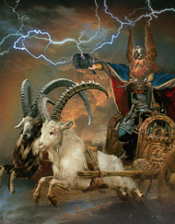
In this ALU, you will write your own myth or legend that explains a place in Florida, giving a background story to provide an explanation for the existence of the place. You will include in this myth all the elements that a myth usually has, including historical evidence, magic and gods. No worries, you will read many examples and get to know the myth genre before you have to write your own!
