All About Me

Level 1 | Level 2 | Level 3* | Level 4
Even with assistance, I am unable to meet the learning targets. | With assistance, I can master some of the learning outcomes.  Vocabulary: acquired traits, inherited traits, dominant/ recessive genes | I can recognize my own and others’ unique personal characteristics. | All of Level 3 including, making connections with family members.
(I)ndependent (P)artner (G)roup
Status | Task: | Order
Optional  (P or G) | We Are Unique: Madagascar Clip  Think about this clip as you progress through today’s tasks
Required  (I) | HG & D Handbook  - How are you unique? (p3)  - What do you know about you? (p4)
Choose 1  (P or G) | Freckle Juice: Choose to read or listen/watch the story.  - Video  - Book Freckle Juice by Judy Blume  (REQUIRED) RAPP Response: Describe the theme, or essential message of the story and support your thinking with text evidence.  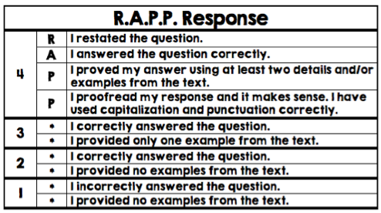
Required  I or P | Genetics & Fingerprinting  - Video: Comparing Fingerprints  - Video: Inherited Traits  - HG & D Handbook:  - “It’s in the Genes” (p6)  - Fingerprinting (p7-9)  - Fingerprinting Data: Answer the following questions about your fingerprints. (I)  - iPad “Socrative App” (code: B3caes)
Choose 1 or both  I, P or G | Genetics & Fingerprinting  - Video: Brain Pop “Heredity”  - Video: Smithsonian “Where do Fingerprints Come From”

